Assignment 2.4

**1. Importance of Name node in Hadoop cluster:**

* Name node is the root directory of an HDFS system. It keeps the directory tree of all file in the file system. So that name node is the important in the hadoop system.

* when the client application want to add/copy/move/delete a file they contact with the namenode and the name node successfully returns the corresponding datanodes list.

* The name node is a Single Point of Failure. when the name node goes down, the file system goes offline.

* If there is more than one name node directory in the configuration, then multiple copies of the meta data will be stored. As long as the directories are in the separate disk, a single disk failure will not corrupt the meta-data.

* The name node is the root node of all the data nodes and it monitors the overall system in HDFS.

* The name node manages and give instructions to the data nodes to do the work. The name node is like a overall coordinator of the hadoop cluster.

**2. Beginners commands for HDFS**

**🡪 hadoop fs –ls**

**This command is used to list the directories and files present in the HDFS**

**🡪 hadoop fs –cat filename(or) pathname**

**This command is used to display the content of the file in the specified file name which is present in the HSDS**

**🡪Put (hadoop fs –put source destination)**

**Put command is used to put the file from the local file system to the hadoop file system.**

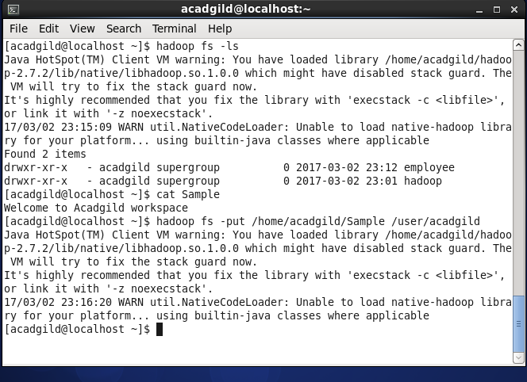

**🡪The ‘sample’ file in the local system is moved to the hadoop file system.**

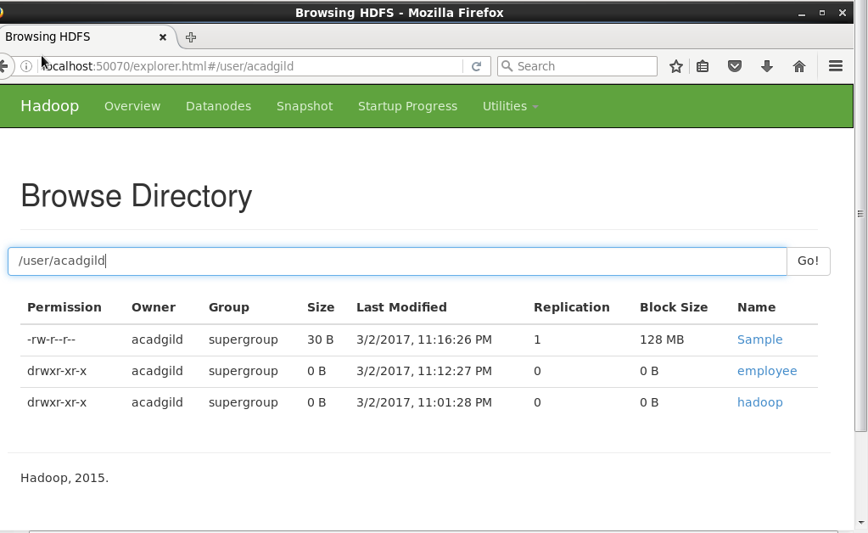

**The screen shot shows the sample file available in the /user/acadgild**

**we can check the availability from the terminal by using the ‘cat’ command.**

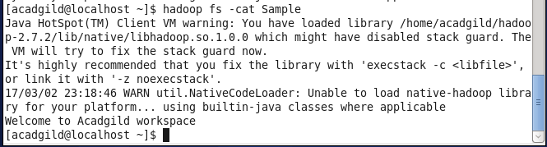

**🡪get (hadoop fs –get source target)**

**The get command is used to fetch the value from the hadoop file system to local file system.**

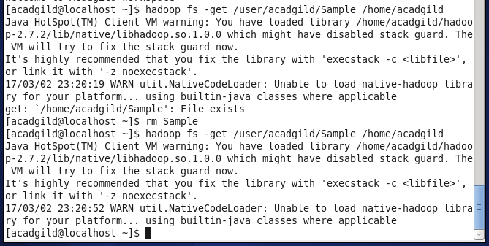

**🡪copyFromLocal (hadoop fs –copyFromLocal source target)**

**Copy from local is same as the ‘put’ command but the difference is it does not check the checksum.**

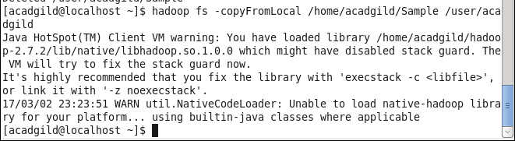

**🡪copyToLocal (hadoop fs –copyToLocal source target)**

**Copy to local is same as the ‘get’ command. But it does not check the check sum option.**

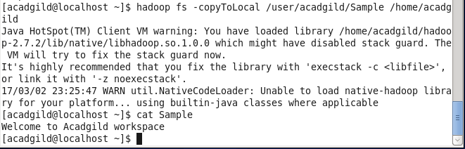

**-->hadoop fs –du –s –h /user/acadgild**

**This command is used to chech the directory space.**

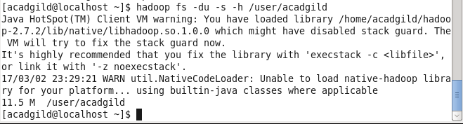

**🡪rm command (hadoop fs –rm filename)**

**Remove command is used to remove the file from the local or hadoop file.**

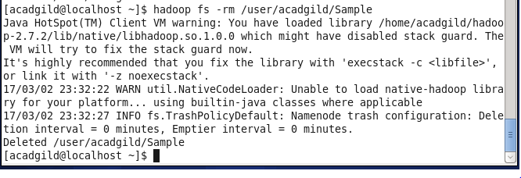

**After removing we can check it in the browser.**

